Functional Programming in JavaScript

MAP

Example:

var array1 = [1, 4, 9, 16];

const map1 = array1.map(x => x \* 2);  
// expected output: Array [2, 8, 18, 32]

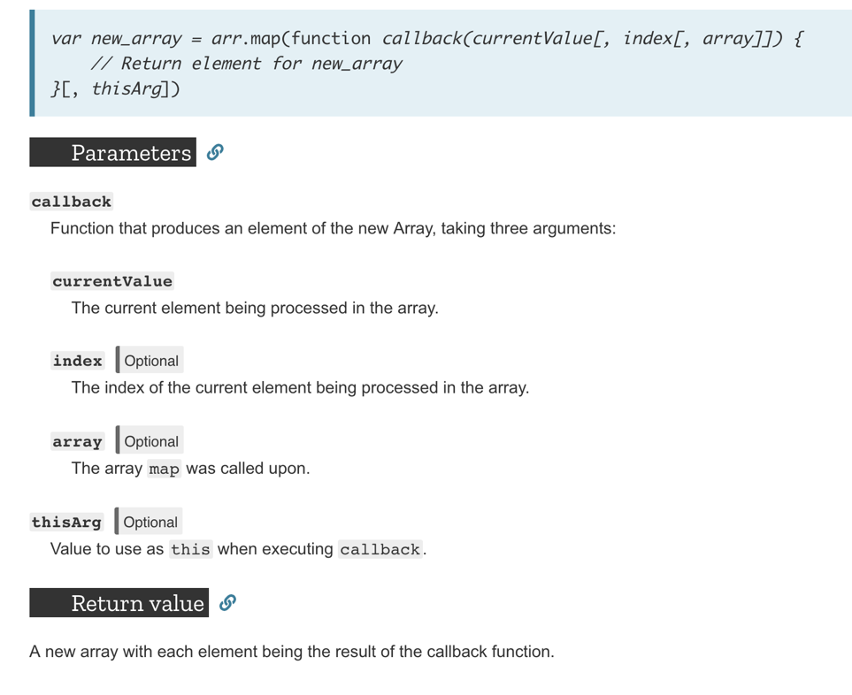

FILTER:

Example:

var words = ['spray', 'limit', 'elite', 'exuberant', 'destruction', 'present'];  
const result = words.filter(word => word.length > 6);

// expected output: Array ["exuberant", "destruction", "present"]

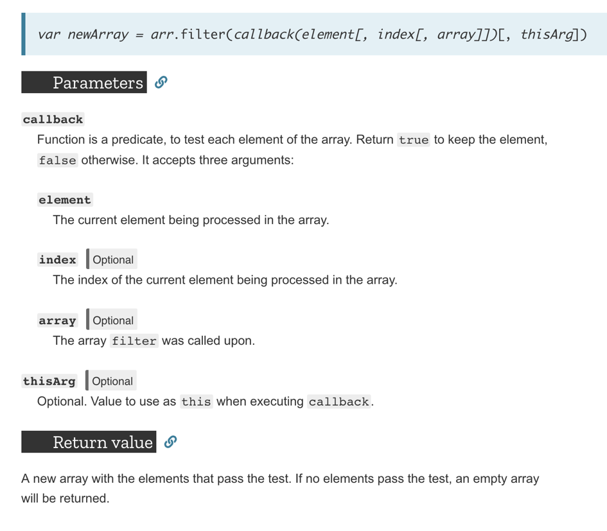

REDUCE:

Example:  
const array1 = [1, 2, 3, 4];

const reducer = (accumulator, currentValue) => accumulator + currentValue;

console.log(array1.reduce(reducer));

// expected output: 10

